**UID LAB EXP 8**

**Storyboard Design for a Food Delivery App using Balsamiq**  
**Name:** Saravanan B  
**Reg. No.:** 230701293

**Title:**  
Create storyboards to represent the user flow for a mobile app (e.g., food delivery app) using Balsamiq

**Aim:**

The aim is to create storyboards representing the user flow for a food delivery app using Balsamiq. This includes showing the progression from restaurant search to order confirmation.

**Procedure:**

1. **Install Balsamiq**  
   • Visit [https://balsamiq.com](https://balsamiq.com/)  
   • Download the appropriate version for your OS (Windows/macOS) or use the web version.  
   • Install and launch the application.
2. **Create a New Project**  
   • Open Balsamiq Wireframes.  
   • Click on “Create New Project.”  
   • Name the project (e.g., "Food Delivery App Wireframe").
3. **Add Wireframe Screens**  
   • Click “+” to add wireframes for different stages of the user journey.  
   • Created screens include:
   * Search Restaurant
   * Menu Display
   * Checkout
   * Order Confirmation
4. **Design Each Screen**  
   • Use drag-and-drop UI components like:
   * Buttons (e.g., Pay)
   * Search Boxes (for restaurant search)
   * Labels and images (for food items)
   * Text areas (for instructions and confirmations)  
     • Maintain a focus on user layout and navigation flow.
5. **Organize the Flow**  
   • Arrange screens in logical order:
   * Home/Search Restaurant
   * Select Food from Menu
   * Checkout
   * Order Confirmation  
     • Use visual arrows or implied transitions between screens to demonstrate flow.

**Output:**

The wireframes include the following screens:

1. **Restaurant Search Screen:**
   * Search bar to find restaurants.
   * Visual options like "KFC" and "Pizza Hut" with logos.
2. **Menu Screen:**
   * Shows items like Garlic Bread and Pizza with images and prices.
3. **Checkout Screen:**
   * Summary of selected items with quantity and total price.
   * "Pay" button to proceed.
4. **Order Confirmation Screen:**
   * Confirmation message with delivery ETA and success icon.

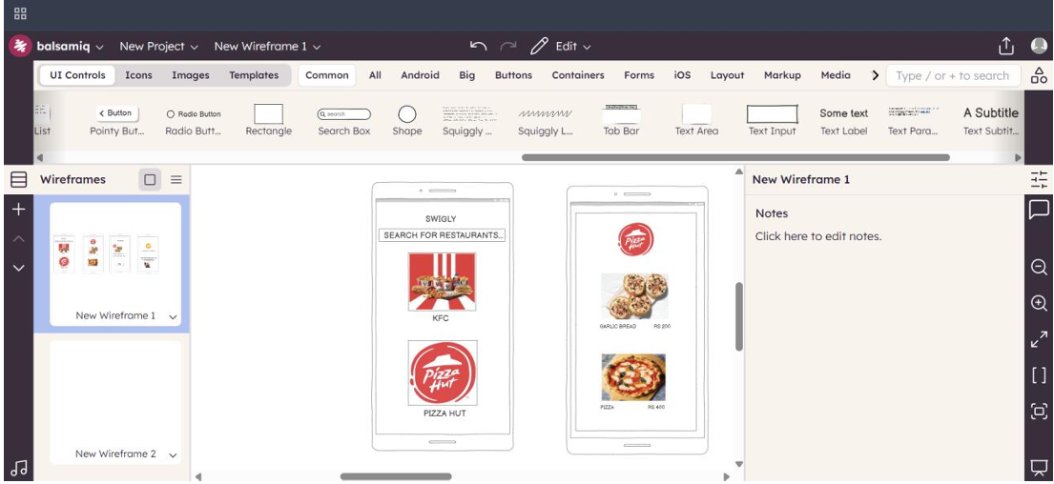

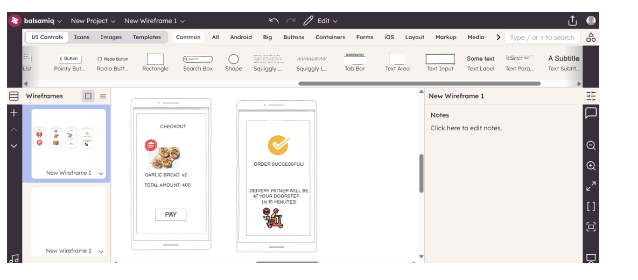

**Result:**

Storyboards created using Balsamiq clearly represent the user flow of a food delivery app. All key screens from restaurant search to order confirmation are included, helping visualize the user experience effectively.